

CHEMISTRY DRAFT SAMPLE EXAMINATION STAGE 3

Section 7 of the WACE Manual: 2008-revised edition outlines the policy on WACE examinations.

Further information about the WACE Examinations policy can be accessed from the Curriculum Council website at
http://newwace.curriculum.wa.edu.au/pages/about_wace_manual.asp

The purpose for providing a sample examination is to provide teachers with an example of how the course will be examined. Further finetuning will be made to this sample in 2008 by the examination panel following consultation with teachers, measurement specialists and advice from the Assessment, Review and Moderation (ARM) panel.
2008/20340



Western Australian Certificate of Education, Draft Sample External Examination
Question/Answer Booklet

CHEMISTRY
Please place your student identification label in this box
STAGE 3

Student Number: In figures

In words

Time allowed for this paper
Reading time before commencing work: Ten minutes
Working time for paper: Three hours

Material required/recommended for this paper

To be provided by the supervisor
Question/answer booklet
Separate multiple-choice answer sheet
Data sheet

To be provided by the candidate
Standard items: Pens, pencils, eraser or correction fluid, ruler, highlighter
Special items: Scientific calculator

Important note to candidates
No other items may be taken into the examination room. It is your responsibility to ensure that you do not have any unauthorised notes or other items of a non-personal nature in the examination room. If you have any unauthorised material with you, hand it to the supervisor before reading any further.

This paper is for students who have completed Units 3A and 3B.
Structure of this paper

Section | Suggested working time | Number of questions available | Number of questions to be attempted | Marks
ONE  Multiple-choice | 50 minutes | 25 | 25 | 50
TWO  Short response | 60 minutes | 9 | 9 | 72
THREE  Extended response | 70 minutes | 6 | 6 | 73
 |  |  | [Total marks] | 195

Instructions to candidates

1. The rules for the conduct of Curriculum Council examinations are detailed in the Student Information Handbook. Sitting this examination implies that you agree to abide by these rules.

2. Answer the questions according to the following instructions.
Section One Answer ALL questions in the separate multiple-choice answer sheet provided.
Section Two Answer ALL questions in the spaces provided in this Question/Answer Booklet.
Section Three Answer ALL questions in the spaces provided in this Question/Answer Booklet.

3. A blue or black ballpoint or ink pen should be used.

4. For full marks, chemical equations should refer only to those species consumed in the reaction and the new species produced. These species may be ions [for example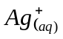], molecules [for example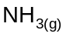,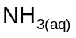,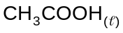, 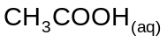] or solids [for example BaSO_{4(s),} Cu_{(s)} 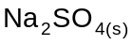].

SECTION ONE—MULTIPLE-CHOICE

This section has TWENTY FIVE (25) questions. Attempt ALL questions.

Answer questions in this section on the separate answer sheet provided.

Suggested working time 50 minutes [50 marks].

Questions 1 refers to the following graph of first ionisation energies.
0
0.5
1
1.5
2
2.5
3
0
2
4
6
8
10
12
14
16
18
20
Atomic Number
1st Ionisation Energy (J/mol)
A
B
C
D
E
- Which of the above elements is most likely a noble gas?
[2 marks]
- A
- B
- C
- D.

- Refer to the equation below to answer question 2.

CaCO₃(s) 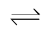 CaO(s) + CO₂ Δ H = 178.3 kJ

Which of the following best represents equilibrium constant expression for this reaction?
[2 marks]
- 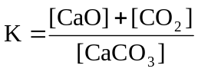

- 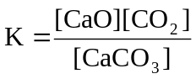
- 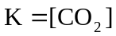
- 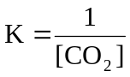.
- Which of the following substances will have the highest melting point?
[2 marks]
- carbon dioxide
- nitrogen dioxide
- silicon dioxide
- sulfur dioxide.

- Consider the following structures

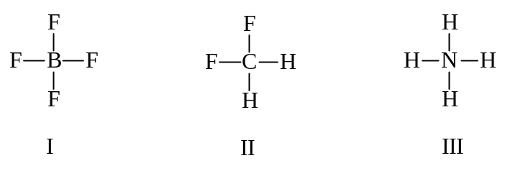
( )
( )
( )

Which of the following statements is true?
[2 marks]
- I and II are ions
- I and III are ions
- II and III are ions
- None of I, II and III are ions.

- In a series of experiments the following observations were made about a colourless liquid.

Experiment | Observation
Liquid was added to potassium dichromate solution | No visible reaction
Liquid was added to sodium metal | Colourless, odourless gas evolved, silvery solid dissolved
Liquid was added to ethanol and heated with concentrated sulfuric acid | Fruity smell produced

Which one of the following substances would produce all of these observations?
[2 marks]
- 2-methyl-2-butanol
- butanoic acid
- 1-butanol
- 2-butanone.

- How many alkenes have the molecular formula C₄H₈?
[2 marks]
- 2
- 3
- 4
- 5.

- Which of the following equations does not represent the donation and acceptance of protons?
[2 marks]
- 2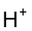+ 2 e⁻ H₂
- + 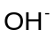 H₂O
- H₂O₂ + 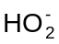 + + H₂O
- H₂C₂O₄ + 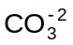 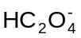 + 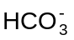.

- Two elements have the electron configurations shown here:
X: 2, 8, 4
Y: 2, 6.

Which of the following represents the most likely formula of a compound formed between
X and Y?
[2 marks]
- XY
- X₂Y
- XY₂
- X₂Y_{3.}

Questions 9 and 10 refer to the following chemical reaction taking place in a sealed container:

2NO(g) + 2H₂(g) N₂(g) + 2H₂O(g) ∆H = 1664 kJ

- Which of these changes to the system would increase the rate of the production of N₂?
I adding a catalyst
II increasing the temperature
III increasing the pressure
IV cooling to cause the H₂O(g) to condense to liquid water.
[2 marks]
- I and II only
- III and IV only
- II and IV only
- I, II and III only.

- Which of the following changes made to the system would increase the equilibrium yield of N₂?
I adding a catalyst
II increasing the temperature
III increasing the pressure
IV cooling to cause the H₂O(g) to condense to liquid water
[2 marks]
- I and II only
- III and IV only
- II and IV only
- I, II and III only.

- Which of the following will conduct electricity?
I molten sulfur
II ammonia solution
III mercury
IV sodium hydroxide solution.
[2 marks]
- IV only
- I and IV only
- I, II and III only
- II, III and IV only.

- Which lists the substances in order of increasing strength of intermolecular forces?
[2 marks]
- N₂ < NH₃ < C₂H₆ < H₂O < CH₃CH₂OH
- C₂H₆ < CH₃CH₂OH < N₂ < NH₃ < H₂O
- N₂ < C₂H₆ < NH₃ < CH₃CH₂OH < H₂O
- NH₃ < N₂ < CH₃CH₂OH < C₂H₆ < H₂O.

- When propan-1-ol is oxidised by excess acidified potassium permanganate, which of the following products would most likely result?
[2 marks]
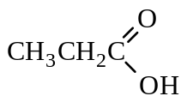
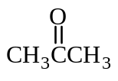
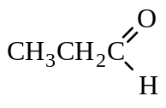
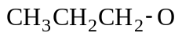
(A)

(B)

(C)

(D)

- Which of the following is not likely to be true for pure Na₂SO₄?
[2 marks]
- It conducts electricity when dissolved in water
- It has a low solubility in hexane
- It is a brittle, crystalline solid
- It is an electrical insulator when molten.

- Which of the following pairs of substances will react together when mixed?
[2 marks]
- Cl₂ + Cu²⁺
- Ni²⁺ + Cu
- Ni²⁺ + Zn
- Zn + Cl⁻ .

- Ionisation of acetic (ethanoic) acid can be represented by this equation:
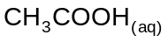 + 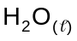 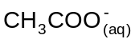 + 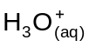
Which of the following would increase the concentration of ethanoate ions?
[2 marks]
- addition of a strong base
- addition of a strong acid
- addition of a weak acid
- dilution with water.

- Refer to the following graph below, which represents the partial pressures of SO₂ and SO₃ in the reaction shown here.

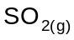 + 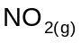 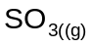 + 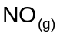 ∆H = 142 kJ

0
10
20
30
40
Time (minutes)
Partial pressure of gases
SO₂
SO₃

At the 20-minute mark, what changes could have been made to the system to produce the effects shown by the graph?
[2 marks]
- The system temperature is increased or the partial pressure of NO is increased
- The system temperature is increased or the partial pressure of NO₂ is increased
- The system temperature is decreased or the partial pressure of NO is decreased
- The system temperature is decreased or the partial pressure of NO₂ is decreased

- How many aldehydes and ketones are there with the molecular formula C₄H₈O?
[2 marks]
- 2
- 3
- 4
- 5.

- In a practical test a student carried out two separate titrations. First, she titrated three 20 mL aliquots of 0.100 mol L⁻¹ nitric acid solution against a standardised 0.050 mol L⁻¹ sodium hydroxide solution. Then, she titrated three 20 mL aliquots of 0.100 mol L⁻¹ acetic (ethanoic) acid against the same standardised 0.050 mol L⁻¹ sodium hydroxide solution. In both titrations, she used phenolphthalein as an indicator.

In order to reach equivalence point:
[2 marks]
- 0.100 mol L⁻¹ acetic acid would require a smaller volume of sodium hydroxide because it is a weak acid
- 0.100 mol L⁻¹ nitric acid would require a smaller volume of sodium hydroxide because it is a strong acid
- 0.100 mol L⁻¹ nitric acid would require a greater volume of sodium hydroxide because it is a strong acid
- 0.100 mol L⁻¹ nitric acid and 0.100 mol L⁻¹ acetic acid would require the same volume because they are the same concentration.

- In the Bayer process, the following reaction occurs:
Al(OH)_{3 (s)} + 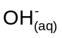 → 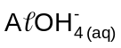

Which of the following statements is correct?
[2 marks]
- Al(OH)_{3 (s)} is oxidised
- Al(OH)_{3 (s)} accepts electrons
- Al(OH)_{3 (s)} acts as an acid
- Al(OH)_{3 (s)} acts as a base.

- Which one of the following statements about dispersion forces in a series of molecules is correct?
[2 marks]
- An increased molecular weight leads to a greater mass of the molecule and hence stronger dispersion forces.
- An increased number of protons and electrons leads to stronger dispersion forces.
- Larger electronegativity differences lead to stronger dispersion forces.
- The presence of an atom such as O or N bonded to H leads to stronger dispersion forces.

- What is the main function of a buffer solution?
[2 marks]
- to neutralise excess acid
- to neutralise excess base
- to react to small changes in pH
- to maintain the neutrality of a solution.

- Which of the following pairs of compounds could be used to prepare a buffer solution?
[2 marks]
- HCl and KCl
- NH₃ and NH₄ Cl
- H₂S and Na₂SO₄
- Na₂CO₃ and NaOH.

- When sulfuryl chloride, SO₂C₂, whose structure is shown below, reacts with water a reaction takes place. If the reaction is not an oxidation/reduction then one of the products of the reaction could be:
S
C
O
C
O
II
II
—
—

[2 marks]
- SO₂
- SC₂
- 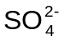
- 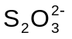.

- A saturated solution of PbC₂ is in contact with excess undissolved solid.

PbC₂(s) Pb²⁺(aq) + 2C⁻(aq)

A small quantity of KC(s) is stirred into the solution. What would happen to the mixture?

I The concentration of C⁻(aq) increases.
II The concentration of Pb²⁺(aq) decreases.
III The mass of PbC₂(s) increases.
IV The KC(s) will not dissolve in this solution.
[2 marks]
- I only
- IV only
- I and II only
- I, II and III only.

END OF SECTION ONE

SECTION TWO—SHORT ANSWER

Section 2 contains NINE (9) questions. Attempt ALL questions in the spaces provided.

In this section, unless asked to write molecular equations, chemical equations should refer only to those species consumed in the reaction and the new species produced. These species may be ions [for example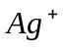(aq)], molecules [for example 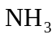(g), (aq),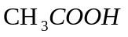(l), 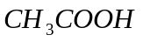(aq)] or solids [for example BaSO₄ (s), Cu (s) 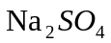(s)].

Suggested working time: 60 minutes [72 marks].

Question 1
Write an appropriate equation for any reactions that occur in the following procedures.
If no reaction occurs write ‘no reaction’.

- Lead nitrate solution is mixed with a sodium sulphate solution.
[2 marks]

- Dilute sulphuric acid solution is added to solid barium oxide.
[2 marks]

- Butane is burnt in air.
[2 marks]

- Silver nitrate solution is added dropwise to a solution of iron (lll) nitrate.
[2 marks]

Question 2 [8 marks]
Write observations for any reactions that occur in the following procedures. In each case describe in full what you would observe, including any:
- colours
- odours
- precipitates (give the colour)
- gases evolved (give the colour or describe as colourless).

If no change is observed, you should state this.

The first example has been done for you.

- Pent-1-ene is shaken with a little bromine water.
The orange coloured bromine water went colourless.

- Acidified potassium permanganate solution is added dropwise to ethanol.
[2 marks]

- Barium sulfate solution is mixed with sodium carbonate solution.
[2 marks]

- Dilute sulfuric acid solution is added to a solution of potassium chromate.
[2 marks]

- Sodium hydroxide solution is added to a 2mol L⁻¹ solution of ammonium nitrate then the mixture is gently heated.
[2 marks]

Question 3
For each species listed in the table below draw the Lewis structure or electron dot diagram, representing all valence shell electron pairs either as or as --
H
H
–
–
–
–
O
••
H
H
••
O
–
–
••
••
••
H
H
O
••
••
[for example, water or or and so on]

 | Species | Structural formula  (showing all valence shell electrons)
 | Ammonium chloride,  NH₄C | [3 marks]
 | Carbonate ion,  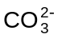 | [3 mark]
 | Ethanal,  (acetaldehyde),  CH₃CHO | [3 marks]

Question 4
Two electrochemical half cells constructed of a zinc and a copper electode in
2 mol L⁻¹ solution of their ions are joined by a salt bridge. A voltmeter is placed in the external circiut to record the cell potential.

Zinc
Copper
Salt bridge
Zn²⁺
Cu²⁺
1.20 V

0.97

V
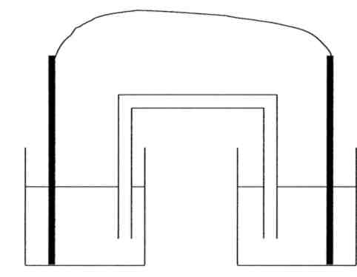

- On the diagram:
[3 marks]
- label the anode and cathode
- show the direction of the movement of the electrons in the external circuit
- show the direction of the movement of the metal ions in the solutions.

- Write the balanced anode and cathode reactions.
[2 marks]
- anode reaction

- cathode reaction

- Describe the two main requirements for a salt that could be used in a salt bridge. Suggest a suitable chemical for the salt bridge in this cell.
[3 marks]

- The value of the E_{cell} using the values from the Standard Reduction Potential table is 1.10 V. Suggest one reason why the actual value of the E_{cell} recorded on the voltmeter is different from the theoretical value.
[2 marks]

Question 5
- Indicate in which of the following organic liquids hydrogen bonding exists by writing either YES or NO in the appropriate box.
[5 marks]

Compound | Is H-bonding present?  (yes or no)
CH₃NH₂
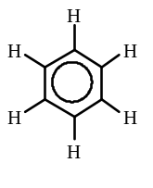
CH₃CH₂CH₂F
CH₃COOH
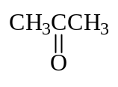

- H-bonding is present in water. Draw a labelled diagram indicating the hydrogen bonding in water.
[2 marks]

Question 6
Ammonia gas can be produced in the laboratory by heating a mixture of ammonium chloride and calcium hydroxide as shown in the unbalanced reaction below.
heat
NH₄C (s) + Ca(OH)₂ (s) → NH₃ (g) + CaC₂ (s) + 2H₂O ()

- If 4.65g of ammonium chloride (formula mass 49.46 g) and 6.64g of calcium hydroxide (formula mass 74.09 g) are mixed together in order to prepare for the production of ammonia, find the limiting reagent. Show all relevant calculations.
[5 marks]

- Describe a simple chemical test and resulting observation to confirm that ammonia had been produced. Support your answer with an equation.
[4 marks]

Question 7
Lim investigated a glass cylinder, fitted with a plunger and filled with a mixture of nitrogen dioxide NO₂, a dark brown gas, and dinitrogen tetroxide N₂O₄, a colourless gas. The two gases exist in dynamic equilibrium, as shown in the equation below. At 25 °C the sample of gas in the cylinder is a light brown colour.

2 NO_{2(g)} ⇌ N₂O_{4(g)}

- Lim wrote in his report that this mixture contains twice as many NO₂ molecules as N₂O₄ molecules. Is this statement true or false? Explain.
[2 marks]
True or false:
Explanation:

When Lim halved the volume of the gas in the cylinder by pushing the plunger downwards he recorded his observations.

- Explain Lim’s observations in terms of the pressure (or partial pressures) of the two gases.
[4 marks]

Observation A. Initially the gas turned a dark brown colour.

Explanation:

Observation B. The dark colour of the gas faded slowly, and finally stayed a constant lighter colour.

Explanation:

- Consider the gas some time after the compression (see below).

?
(i) before compression
(ii) immediately after compression
(iii) some time after compression

If Lim could compare the colour of the gas mixture some time after compression, would he record the colour in (iii) as: lighter than in (i), about the same as in (i), or darker than in (i)?
[2 marks]

Answer: the colour in (iii) would be ____________________________ the colour in (i).

Explanation:

Question 8
- There are two isomeric alcohols with the molecular formula C₃H₈O.

- Draw the structural formula of the two alcohols.
[2 marks]

- Name the two isomers that you have drawn.
[2 marks]

- The two alcohols form different reaction products when reacted with acidified potassium permanganate.

Complete the table below by writing the name of the alcohol in one column and the name of the oxidation product in the other column.
[2 marks]
Name of alcohol | Name of oxidation product
Isomer 1

Isomer 2

Question 9
Acetic (ethanoic) acid is a weak acid and exists in an aqueous equilibrium shown in the equation below.

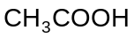(aq) + H₂O (l) + heat ⇌ 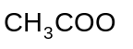(aq) + 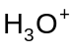(aq)

- Write an equilibrium expression for this reaction.
[2 marks]

- The value of K in this system is 1.78 x 10⁻⁵ at 25 °C. If the temperature is increased to 40 °C, will the value of K increase, stay the same or decrease?
[1 mark]

Explain your answer.
[4 marks]

END OF SECTION TWO
SECTION 3—Extended Response

Section 3 has SIX (6) questions. Attempt ALL questions in the spaces provided below.

In descriptive responses, marks are awarded for relevant chemical content, including equations, diagrams and illustrative examples of the chemistry you are describing.

Calculations are to be set out in detail. Marks will be awarded for correct equations and clear setting out, even if you cannot complete the calculation. Express numerical answers to three (3) significant figures and provide units where appropriate.

Suggested working time: 70 minutes [73 marks].

Question 1 (15 marks)
The pH of blood is maintained through buffering. The major buffer system present in blood is based on a carbonic acid/hydrogencarbonate ion buffer. The presence of these substances keep the pH of blood to about 7.4.

When carbon dioxide enters the blood stream as a product of cellular respiration as shown in equation (i), the following reactions occur:

- C₆H₁₂O₆ (aq) + 6 O₂ (aq) → 6 CO₂ (aq) + 6 H₂O ()

- CO₂ (aq) + H₂O () ⇌ 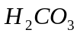 (aq)
- 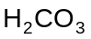 (aq) ⇌ 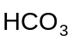(aq) + 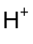(aq)
- CO₂ (aq) ⇌ CO₂ (g) (this equation (iv) occurs in the lungs)

- If the pH of blood is normally 7.4 calculate the [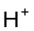]
[2 marks]

- Write an equilibrium expression K for reaction (ii)
[2 marks]

- Hyperventilation, or rapid breathing, decreases the amount of carbon dioxide in the lungs and therefore the concentration of carbon dioxide dissolved in the blood. This leads to changes in the pH of the blood.

- Indicate if the following statement is true or false.

Hyperventilation will lower the pH of the blood.

Circle the correct response. True False
[1 mark]

- Explain, using the equations provided, the reason for the initial change in the pH of the blood.
[4 marks]

- Strenuous activity increases the rate of respiration. Explain the effect that an increase in the rate of respiration has on the pH of blood, using the equations provided.
[3 marks]

- The (aq) ion is an effective buffer in both acidic and basic solutions. Explain how this is possible using equations to support your answer.
[3 marks]

Question 2 [13 marks]
Olive oil and grapeseed oil have similar structural formula

Olive oil CH₃(CH₂)₄CH₂CH₂CH₂CH=CH(CH₂)₇COOH
(Formula mass 282.45g)

Grapeseed oil CH₃(CH₂)₄CH=CHCH₂CH=CH(CH₂)₇COOH
(Formula mass 280.44g)

Unsaturated oils can be converted into saturated oils by reacting the oil with hydrogen gas in the presence of a palladium catalyst.

A batch of olive oil was suspected to have had grapeseed oil accidentally added to it. To test the purity of the olive oil, a chemist hydrogenated a 19.74 g sample of oil. It required 835 mL of hydrogen gas at 150 °C and (300.0 kPa) to completely hydrogenate the oil sample.

- Explain with the aid of simple equations why olive oil and grapeseed oil would require different volumes of hydrogen to completely saturate 1 mole of each of the oils.
[4 marks]

- Calculate the volume of hydrogen at 150 °C and (300.0 kPa) needed to completely hydrogenate a 19.74g of pure olive oil.
[5 marks]

- Answer these questions using the information that you have been given and the answer from (b):

- Has the olive oil been contaminated with grapeseed oil?
[2 marks]

- Give a brief explanation in support of your answer. A calculation is not required.
[2 marks]

Question 3 [11 marks]
A student investigates the effect of the concentration of hydrochloric acid on the rate of oxidation of zinc in the laboratory. She adds 40.0 mL of 1.00 mol L⁻¹ hydrochloric acid to 20.0 g of zinc in a conical flask and measures the rate at which hydrogen is given off.

Time | 0 | 0.5 | 1.0 | 1.5 | 2.0 | 3.0 | 5.0 | 7.0 | 8.0 | 10.0
(min)
Loss in | 0 | 0.19 | 0.35 | 0.47 | 0.63 | 0.72 | 0.82 | 0.86 | 0.88 | 0.88
mass (g)

The flask and contents were immediately weighed and a stopwatch started. The mass of the flask and contents were noted as the reaction proceeded. The table indicates the loss in mass at various times.

- List two variables you would expect to control in this experiment.
[2 marks]

- List one variable you have to measure and one other variable that you could measure to determine the rate of reaction.
[2 marks]
Variable you have to measure__________________________________________
Variable that you could measure________________________________________
- Plot a graph of 'loss in mass' against time, on the grid below.
[5 marks]

- List two potential sources of uncertainty in experimental measurements in this investigation and how you would minimise them.
[2 marks]

Question 4 [12 marks]
When copper(II)sulfate is dissolved in water a blue coloured solution of Cu²⁺(aq) ions are formed and when treated with excess concentrated ammonia solution the initial precipitate of copper hydroxide dissolves to give a deep blue solution. When ethanol is added to the solution, deep blue crystals precipitate. When the solution is filtered the crystals smell of ammonia, and an unstable salt with formula Cu(NH₃)_{x}SO₄.yH₂O has been formed.

- When 1⋅4009 g of the unstable salt is heated at 300°C, the salt decomposes and the ammonia is driven off. The ammonia that is produced is captured and found to occupy 539⋅1 mL at 250^{C} and 104.5 kPa. Calculate the number of moles of ammonia (x) in the 1⋅4009 g sample of the complex salt.
[2 marks]

- Calculate the mass of the ammonia in the 1.4009 g sample.
[2 marks]

- Another 1⋅4009 g of the unstable salt is heated at 300°C driving all off the ammonia and water leaving only 0.9055g of copper(II)sulfate behind. Calculate the mass of water in a 1.4009 g sample of the unstable salt.
[3 marks]

- Calculate the number of moles of water in a 1⋅4009 g sample of the unstable salt.
[1 mark]

- Calculate the number of moles of copper(II)sulfate in the 0.90551g sample of
copper(II) sulfate.
[1 mark]

- Using the information from (a) to (e) determine the empirical formula of the unstable copper salt.
[3 marks]

THIS SPACE HAS BEEN LEFT BLANK INTENTIONALLY

Question 5 [12 marks]
Borax, Na₂B₄O₇.10H₂O, can be used as a primary standard in acid-base titrations. It reacts according to the following equation:

B₄O₇²⁻ + 2H⁺ + 5H₂O → 4H₃BO₃

2.334 g of borax was dissolved in a 250.0 mL volumetric flask and the flask filled to the mark with distilled water. 20.00 mL aliquots of the borax solution were titrated against a hydrochloric acid solution and the following results were obtained.

 | 1 | 2 | 3 | 4
Final reading (mL) | 20.20 | 36.80 | 21.07 | 37.70
Initial reading (mL) | 2.55 | 20.20 | 4.35 | 21.07
Titration volume (mL)

- Calculate the concentration of the borax solution.
[3 marks]

- Complete the table and calculate the average titration volume.
[2 marks]

- Calculate the concentration of the hydrochloric acid solution.
[5 marks]

- What two properties are required of a primary standard like borax?
[2 marks]

Question 6 [10 marks]
The following table gives information about the solubility of some solutes in the solvents water and hexane.

Solute | Solvent
Solute | Water | Hexane
methanol | soluble | slightly soluble
pentan-1-ol | slightly soluble | soluble
sodium chloride | soluble | insoluble

- Discuss the type of and the relative strength of the intermolecular and or interionic forces displayed by each of the solutes.
(6 marks)

- Account for the differences between the solubility of pentan-1-ol in water and hexane.
[Hint: like dissolves like is a statement and not an explanation.]
[4 marks]

END OF PAPER

ACKNOWLEDGEMENTS

Published by the Curriculum Council of Western Australia
27 Walters Drive
OSBORNE PARK WA 6017

